Solution Requirements
This section defines both functional and non-functional requirements of the system.
3.1 Functional Requirements
- The system shall collect real-time motor sensor data
- The system shall preprocess raw data
- The system shall predict motor temperature using ML models
- The system shall display actual and predicted temperature
- The system shall generate alerts when unsafe conditions are detected
- The system shall store historical data for analysis

3.2 Non-Functional Requirements
Performance
- Low latency predictions
- Real-time data handling
Reliability
- High prediction accuracy
- Fault-tolerant data handling
Scalability
- Ability to support multiple motors
- Expandable data storage

Security
- Secure access control
- Data integrity protection
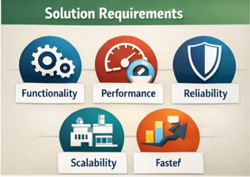
Usability
- Simple and intuitive interface
- Minimal user training required

3.3 System Constraints
- Availability of quality sensor data
- Computational limitations
- Network connectivity

